Project Plan
Group IT1B, Year 1, Period 2
[2025/11/08 – 2026/01/16]

Table of Contents
- Project Goal 3
- Project Result 3
  - Interim Results
  - End Results
- Project Boundaries 3
- Project Phases 3
  - Phase I – Planning and Preparation
  - Phase II – Implementation
  - Phase III – Documentation and Finalisation
- Project Quality 5
  - Roel Grit Project Management Method
  - Infrastructure and Operating System
  - Windows Server Configuration
  - Coding Standards
  - Version Control
  - Design Workflow
  - Communication
  - Team Availability
- Charts 7
  - Network Diagram/PERT Chart
  - Gantt Chart

- Project Goal
The project goal is to develop a working environment, which employees can use both at home and in the office.
- Project Result
  - Interim Results
In the first phase of the project, milestones (such as the completion of a document) are considered an interim result. In the second phase, completion of a new function or the installation/configuration of a server feature is to be considered an interim result.
  - End Result
An environment where employees can collaborate easily, by sharing files using a global network. Furthermore, all employees have their own private folders, which are only accessible to them.
- Project Boundaries
The project length is 8 weeks. The deadline is 16 January 2026.
- Project Phases
  - Phase I – Planning and Preparation
    - Code of Conduct
The Code of Conduct aims to provide an outline for groupwork, regulating the manner in which meetings are to be held, the communication between members and it outlines other general rules. The Code of Conduct is to be unanimously accepted and signed by all team members to be considered valid.
    - Documentation
To ensure accountability, all team members are required to document their work in a digital format. Every project-related task must be recorded in a designated document, including the date and the name of the team member responsible.
    - Project Discussion
To ensure the highest level of team efficiency, all work segments will be distributed equally among the team members. Tasks will be completed simultaneously whenever possible. In addition, each team member will remain aware of the others’ work and make sure they understand those tasks as well, ensuring everyone has a complete understanding of the entire project.
    - Client Consultation
Client consultation will take place shortly after discussion about the project. Its goal is to ask for clarification regarding project details to make sure that every requirement will be met.
  - Phase II – Implementation
    - System Design
After group discussion and meeting with the client, first steps will be taken in designing the architecture for the network, AD structure, file server, web server and firewall.
    - (Optional) Second Client Consultation
To make sure our work is done properly, second meeting with the client might take place.
    - Installation And Configuration
Based on designs, all necessary software will be installed and configured.
  - Phase III – Documentation & Finalisation
    - Team Understanding & Review
All team members will make sure that they understand and can explain every aspect of the project and its software.
    - Project Documentation Submission
All prepared documentation will be sent along with the completed project.
- Project Quality
  - Roel Grit Project Management Method
- Tools: Roel Grit – Project Management
- Action: Use the framework to structure planning, execution, quality checks and finalization.
  - Infrastructure and Operation System
- Tools: Proxmox, IPFire; Windows Server 2022, Windows 11, Linux (Zorin OS 18 Core)
- Action: For virtualization Proxmox will be used, and for the firewall IPFire is the tool used. The Windows Server will be used for the configuration of the database and those are the OS that client says will be used by the end users.
  - Windows Server Configuration
- Server Roles & Services
- Tools/Standards: Active Directory, DHCP, File Server, PowerShell scripting
- Action: Tools and standards for the configuration of the Windows Server.
- Web & Database Stack
- Tools: NGINX, MySQL, phpMyAdmin
- Action: We will use NGINX and MySQL to host the web application and store its data on the Windows Server infrastructure. phpMyAdmin will serve as the interface to manage the database and visualize the data structure.
  - Coding Standards
- Tools/Standards: HTML5, CSS3, PHP8; VS Code
- Action: Used tools to create the login page.
  - Version Control
- Tools: Git, GitHub, Work Document
- Action: Git and GitHub will be used to make the login page, Work Document to control what each person is doing.
  - Design Workflow
- Tools: Figma, Microsoft Visio
- Action: Design login page; Tool used for the making of Network Diagram.
  - Communication
- Tools: WhatsApp
- Action: Will be used to communicate between the team.
  - Team Availability
    - Tools: Code of Conduct
    - Action: Define required team availability.
- Charts
  - Network Diagram/PERT Chart
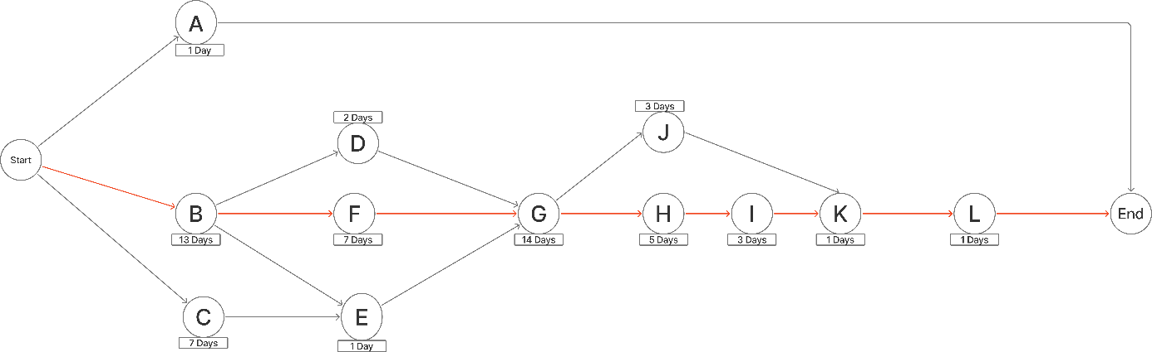
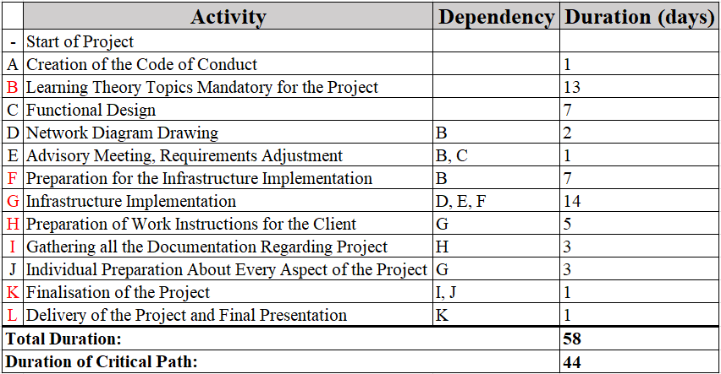
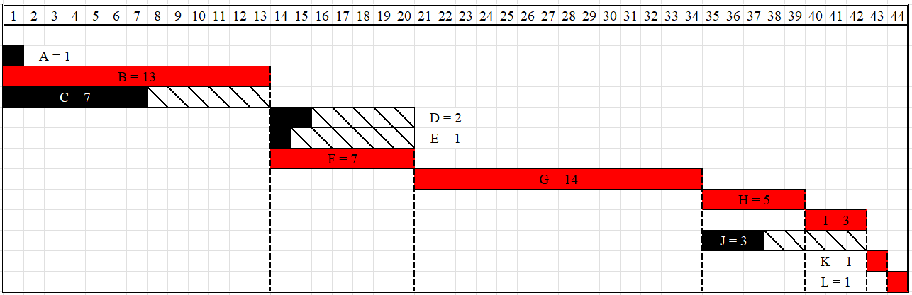
  - Gantt Chart

